# EXPERIMENT No.: 06 VOLTAGE SHUNT FEEDBACK AMPLIFIER

**AIM:** To obtain the frequency response characteristics of a Voltage shunt amplifier with and without feedback and determine the upper and lower cut off frequencies.

**OBJECTIVE:** To study about the frequency response characteristics of a Voltage shunt amplifier with and without feedback and determine the upper and lower cut off frequencies.

**APPARATUS:**

|  |  |  |  |  |
| --- | --- | --- | --- | --- |
| **S No.** | **Apparatus** | **Type** | **Range** | **Quantity** |
| 1 | **Transistor** | **BC 107** |  | **1** |
| 2 | **Resistors** |  | **33KΩ (1), 4.7KΩ (1), 2.2KΩ (1), 8.2KΩ (1), 1KΩ (1), 2.7KΩ (1)**  **and 10KΩ (1)** | **7** |
| 3 | **Capacitors** |  | **10μf** | **3** |
| 4 | **Signal Generator** |  |  |  |
| 5 | **Regulated Power Supply** |  |  |  |
| 6 | **Bread Board with connecting wires** |  |  |  |
| 7 | **CRO with probes** |  |  |  |

**THEORY:**

In voltage shunt feedback amplifier, the feedback signal voltage is given to the base of the transistor in shunt through the base resistor.

This shunt connection tends to decrease the input resistance and the voltage feedback tends to decrease the output resistance. In the circuit base resistor appears directly across the input base terminal and output collector terminal. A part of output is feedback to input through base resistor and increase in IC decreases IB. Thus, negative feedback exists in the circuit. So, this circuit is also called voltage feedback bias circuit. This feedback amplifier is known **a trans resistance amplifier**. It amplifies the input current to required voltage levels. The feedback path consists of a resistor and a capacitor.

**CIRCUIT DIAGRAM:**

CIRCUIT DIAGRAM IN CASE OF WITH FEEDBACK

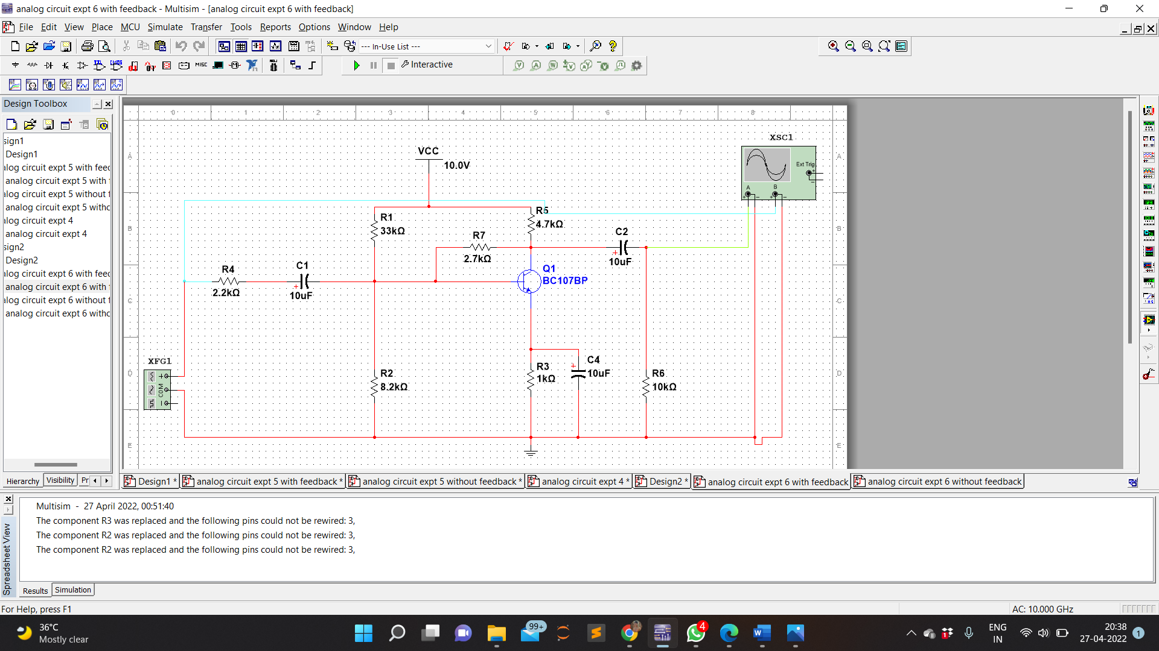

CIRCUIT DIAGRAM IN CASE OF WITHOUT FEEDBACK

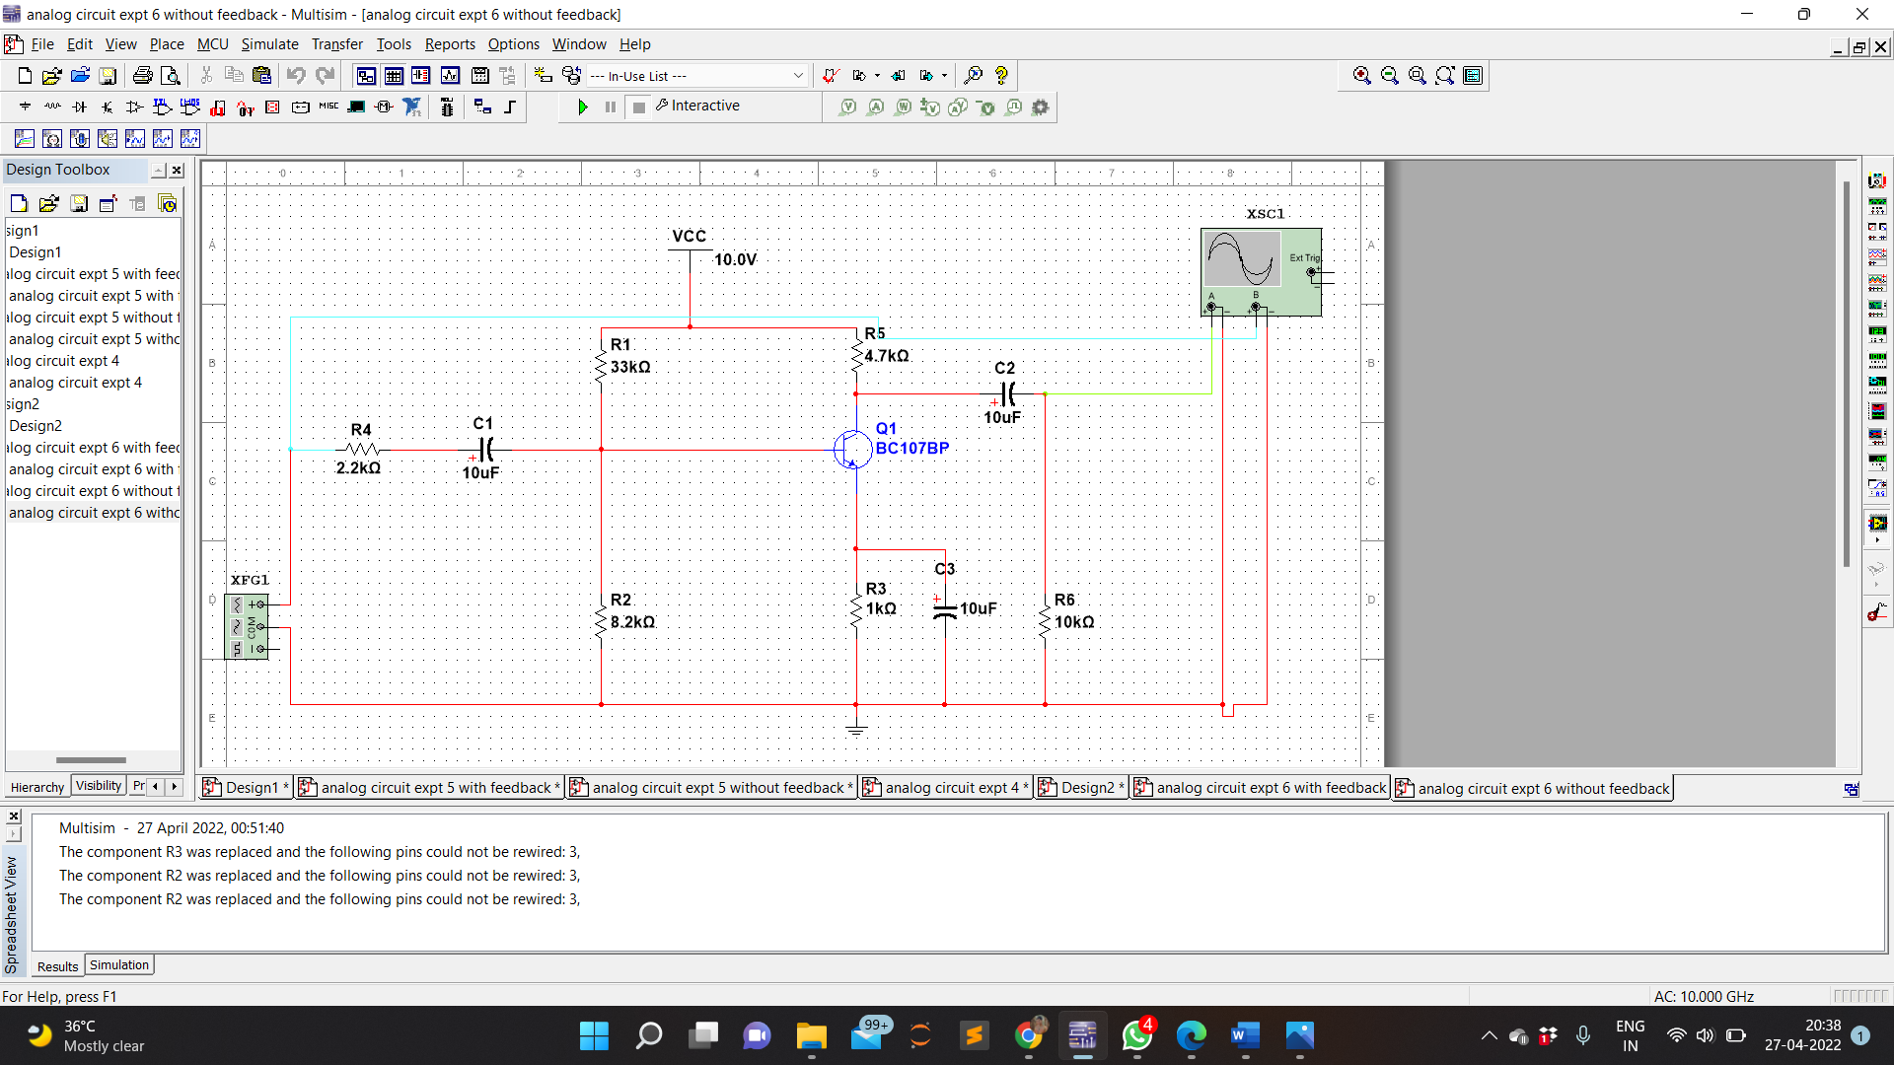

**PROCEDURE:**

1. Connections are made as per the circuit diagram.
2. A 10V DC supply is given to the circuit for biasing.
3. The circuit is connected without feedback i.e., without RF
4. At certain amplitude of input signal (say 20mV at 1 kHz) is kept constant using the function generator and for Different Frequencies the output voltage from CRO is noted.
5. Now, the circuit is connected with feedback i.e., with RF.
6. By keeping the input signal constant the output voltages for different frequencies are noted from CRO.
7. Gain with and without feedback is calculated from the Formula

**Gain = 20 log Vo / Vi**

**(dB)**

Where VO is output voltage, VI is input voltage.

**OBSERVATION:**

WAVEFORM IN CASE OF WITH FEEDBACK

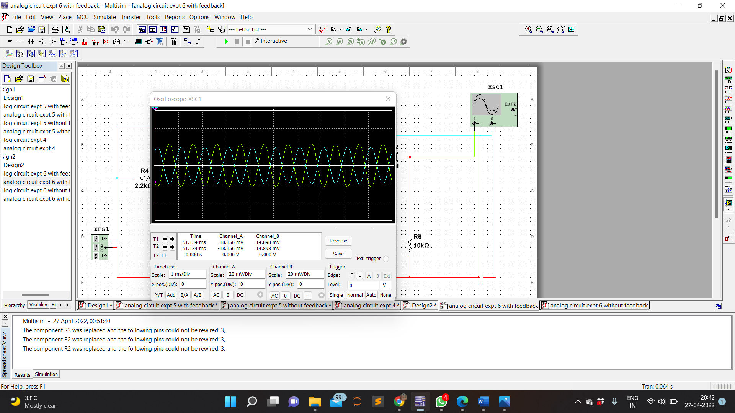

WAVEFORM IN CASE OF WITHOUT FEEDBACK

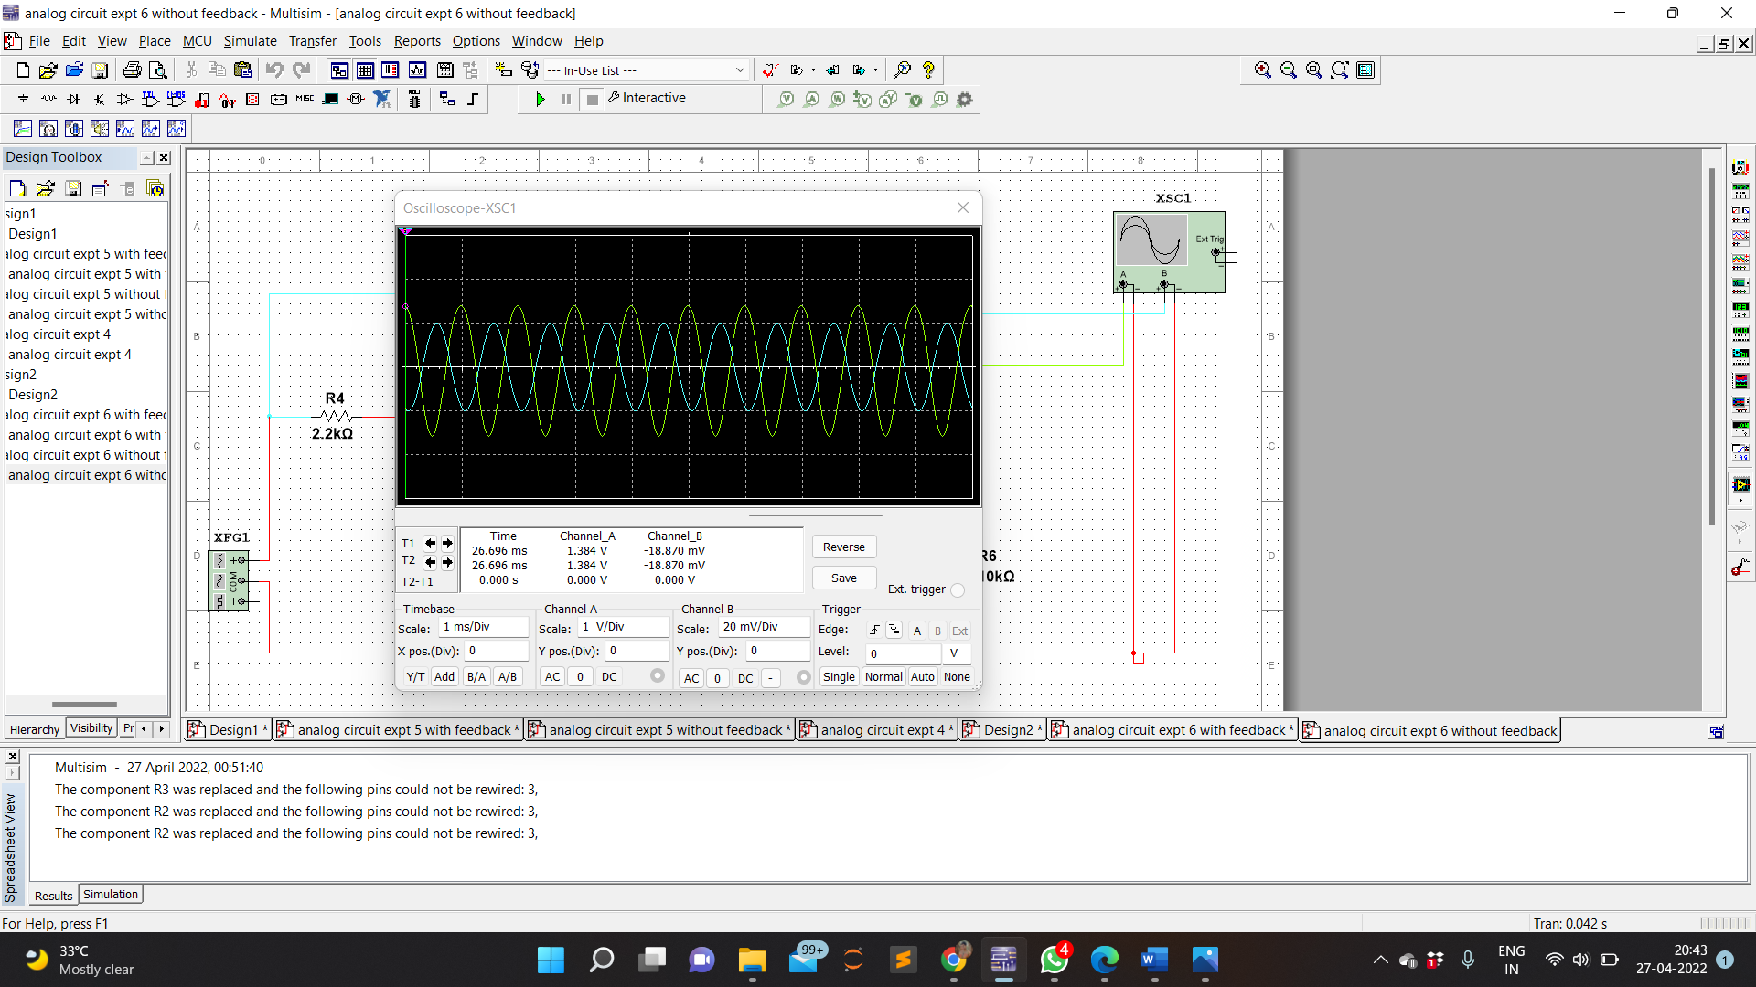

BANDWIDTH IN CASE OF WITH FEEDBACK

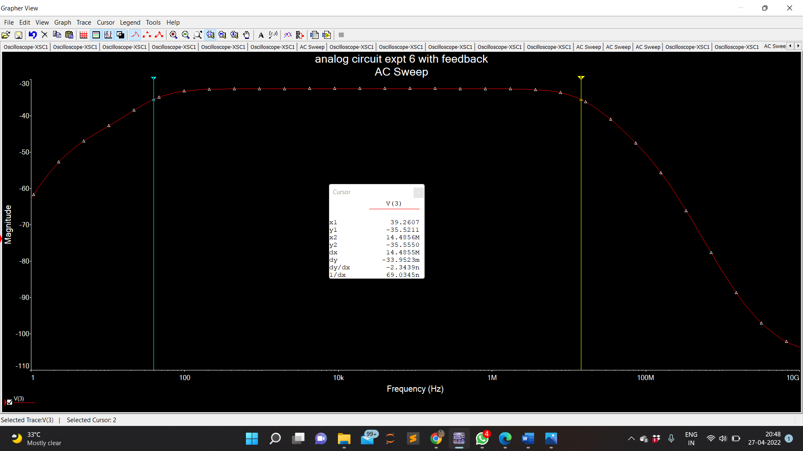

BANDWIDTH IN CASE OF WITHOUT FEEDBACK

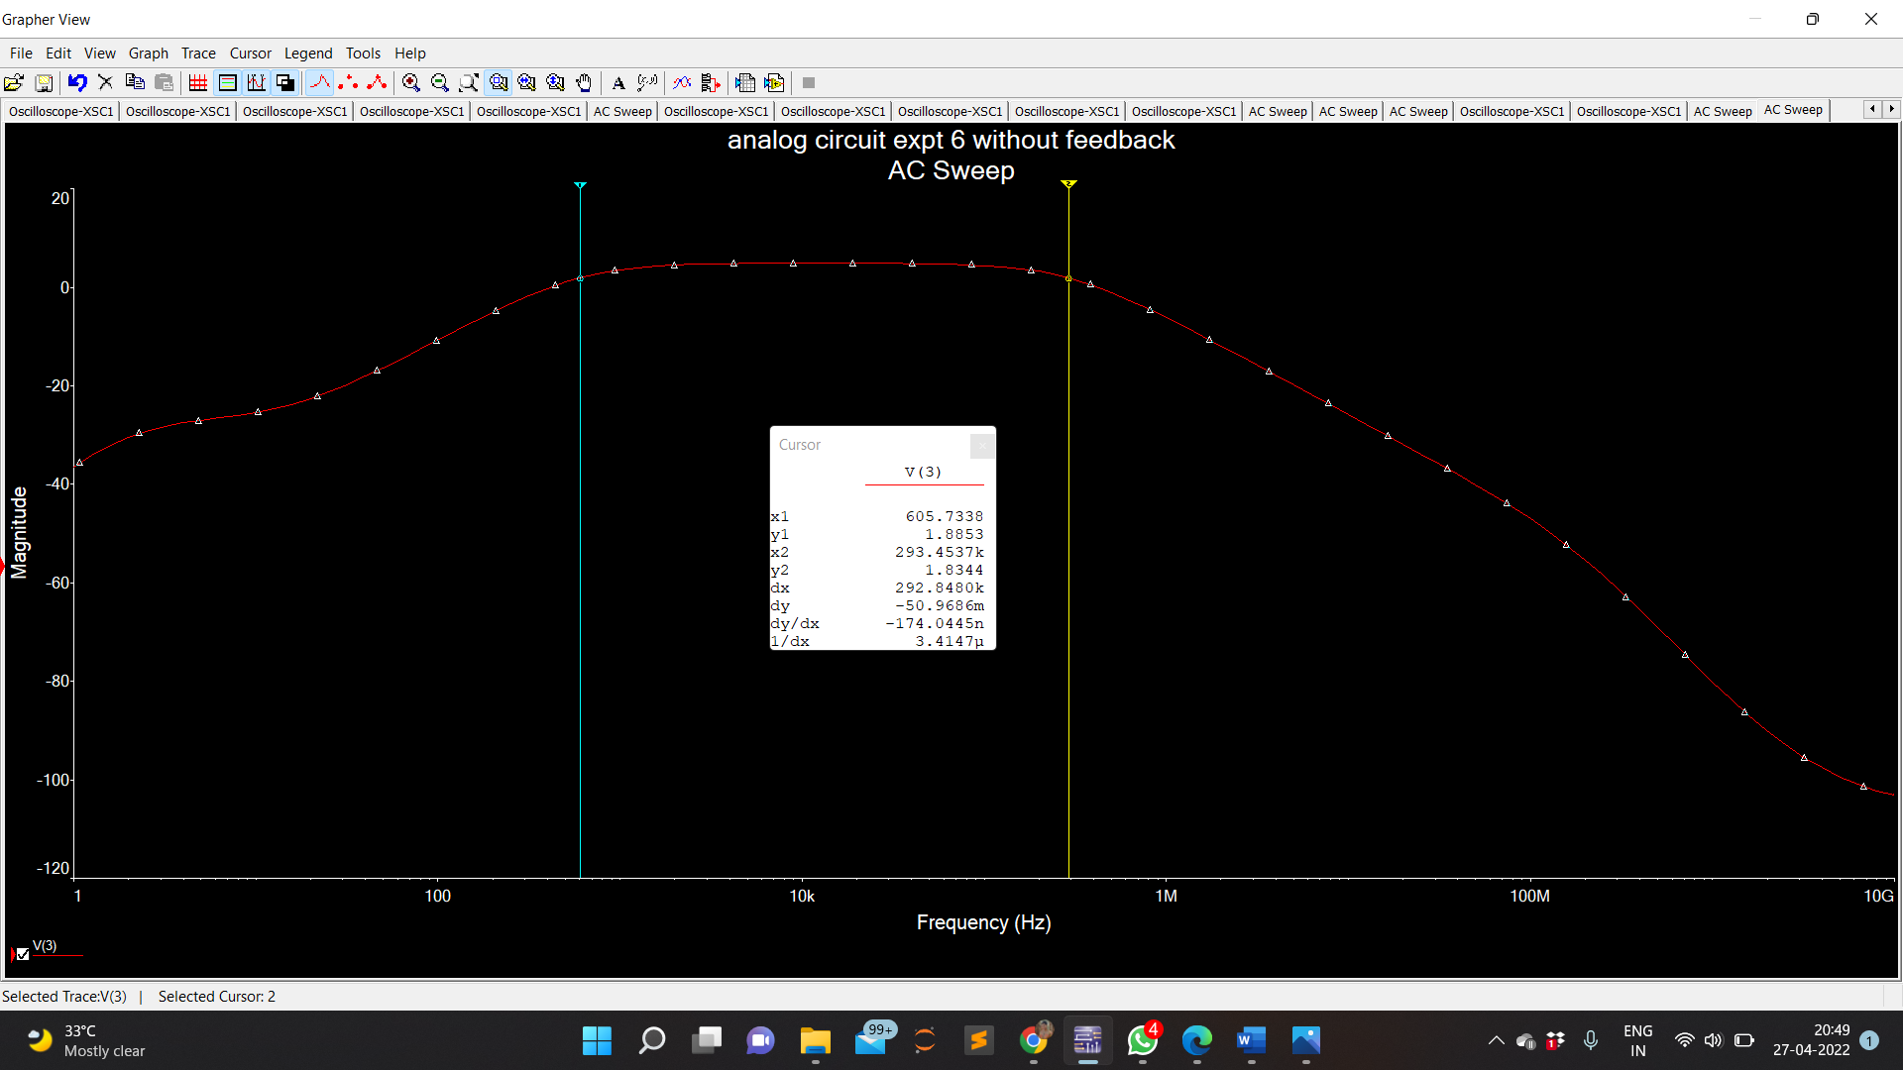

**OBSERVATION TABULAR FORM:**

**WITH FEEDBACK: I/P VOLTAGE Vi = 20mV =0.02V**

|  |  |  |  |
| --- | --- | --- | --- |
| **S.NO.** | **FREQUENCY (Hz)** | **O/P VOLTAGE**  **(Vo)** | **Gain in dB = 20 log Vo / Vi** |
| 1  2  3  4 | **1.0k 10k**  **100.91k**  **44.89M** | 0.02030  0.02050  0.02052  0.02045 | 16.12m  22.24m  22.34m  19.32m |

**WITHOUT FEEDBACK:** **I/P VOLTAGE Vi = 20mV =0.02V**

|  |  |  |  |
| --- | --- | --- | --- |
| **S.NO.** | **FREQUENCY (Hz)** | **O/P VOLTAGE**  **(Vo)** | **Gain in dB = 20 log Vo / Vi** |
| 1  2  3  4 | **1.0K**  **10.03K**  **12.60K**  **109.4K** | 0.04184  0.04178  0.03360  0.04185 | 641.12m  641.17m  450.70m  641.47m |

**CALCULATION:**

**WITH FEEDBACK-**

1. Frequency = 1K Hz
   1. input = 0.02V

V output = 0.02030 V

Gain = 20log(Vo/Vi)

= 16.12 m db

1. Frequency = 10K Hz
   1. input = 0.02V

V output = 0.02050 V

Gain = 20log(Vo/Vi)

= 22.243 m db

1. Frequency = 100.91K Hz
   1. input = 0.02V

V output = 0.02052 V

Gain = 20log(Vo/Vi)

= 22.34 m db

1. Frequency = 44.89M Hz
   1. input = 0.02V

V output = 0.02045 V

Gain = 20log(Vo/Vi)

= 19.32 m db

**WITHOUT FEEDBACK:**

1. Frequency = 1.0K Hz
   1. input = 0.02V

V output = 0.02030 V

Gain = 20log(Vo/Vi)

= 641.12 m db

1. Frequency = 10.03K Hz V input = 0.02V
   1. output = 0.02030 V

Gain = 20log(Vo/Vi)

= 641.177 m db

1. Frequency = 12.60K Hz
   1. input = 0.02V

V output = 0.02030 V

Gain = 20log(Vo/Vi)

= 450.70 m db

1. Frequency = 109.4 K Hz
   1. input = 0.02V

V output = 0.02030 V

Gain = 20log(Vo/Vi)

= 641.47 m db

CONCLUSION:

In this experiment we used a 2N3904 transistor to get the output gain values. The gain value comes different for the circuit which has the feedback and for the circuit whithout the feedback. Here a capacitor works as the feedback.